**Cephalosporins**

* **The cephalosporins are β-lactam antibiotics isolated from Cephalosporium spp. or prepared semi synthetically.**
* **They are penicillin analogs where the thiazolidine in penicillins has been replaced by dihydrothiazine.**

**Spectrum of Activity**

* **The cephalosporins are considered broad-spectrum antibiotics**
* **It much more resistant to inactivation by β-lactamases.**
* **They are bactericidal.**

**Adverse reaction**

* **Nontoxic compounds that, because of their selective actions on cell wall cross-linking enzymes.**
* **Allergic reactions are believed to occur less frequently with cephalosporins than with penicillins. The issue of cross-sensitivity between the two classes of β-lactams is very complex, but the incidence is considered to be very low estimated between 3% and 7%.**
* **Cephalosporins containing an N-methyl-5-thiotetrazole (MTT) moiety at the 3-position (e.g., cefamandole, cefotetan, cefmetazole, moxalactam, and cefoperazone) can cause hypoprothrombinemia as well as disulfiram-like acute alcohol intolerance.**

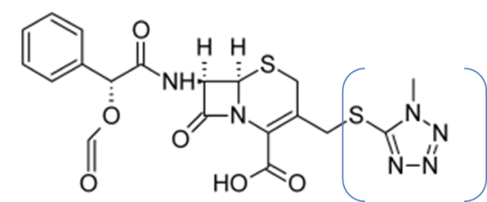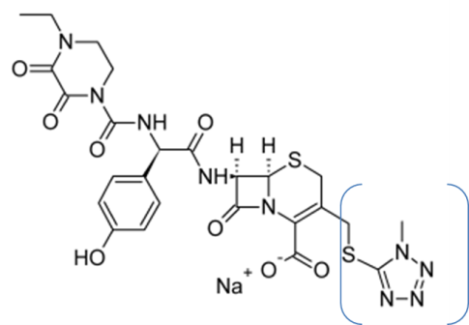

**Nomenclature**

* **Due to the presence of different substitution at (position 3), cephalosporines do not have a specific nomencalture form.**
* **Cephalosporanic acids, this practice applies only to the derivatives that have a 3-acetoxymethyl group at position 3.**



**Chemical Degradation**

**Two sites at 7-acylaminocephalosporanic acid derivatives, undergo chemical degradation:**

1. **3-acetoxylmethyl group: is the more reactive group**

* **In addition to its reactivity to nucleophilic displacement reactions.**
* **It also undergoes solvolysis in strongly acidic solutions to form the desacetylcephalosporin derivatives. The latter lactonize to form the desacetylcephalosporin lactones, which are virtually inactive.**

**2. The 7-acylamino group of some cephalosporins can also be hydrolyzed under:**

* **Effect of enzyme (acylases)**
* **Non-enzymatic conditions to give 7-ACA (7- aminocephalosporanic acid) or 7-ADCA (desacetyl 7- aminocephalosporanic acid) derivatives. Following hydrolysis or solvolysis of the 3-acetoxymethyl group, 7-ACA also lactonizes under acidic conditions.**

Fig. 1: Degradation of cephalosporins.

**General SAR for Cephalosporins**

* **The β-lactam in the cephalosporins is more stable to acid hydrolysis than that observed in penicillins due to decrease in ring strain and due to delocalization of the nitrogen lone pair into the double bond of the dihydrothiazine ring which decreases its basicity, thus decrease protonation of nitrogen.**
* **The presence of the 3-acetoxyl (good leaving group) at position 3 is responsible for poor oral absorption (not given orally), because of solvolysis and lactonization under acidic conditions.**



* **An N-methyl-5-thiotetrazole (MTT) moiety at the 3-position enhanced potency and prevent metabolism by deacetylation.**

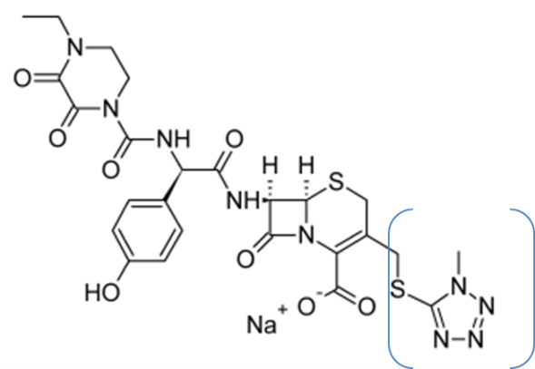

* **Replacing the 3-acetoxyl with 3-(carbamate, CH3, Cl, CH=CHCH2, CH2-O-CH3, hetrocyle)→ provide oral activity, or acid stability.**



* **To enhance oral absorption in certain cephalosporins, esterification the 3-carboxylic acid group to form acid-stable, lipophilic esters that undergo hydrolysis in the plasma. Examples :**

**Cefuroxime axetil and cefpodoxime proxetil oral active prodrugs**



* **Parenteral cephalosporins lacking a hydrolyzable group at the 3-position are not subject to hydrolysis by esterases. Ex.: Cephradine is the only cephalosporin that is used both orally and parenterally.**

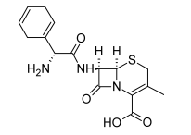 Cephradine

**Inactivation of parenteral cephalosporins containing a 3-acetoxymethyl substituent (e.g., cephalothin, cephapirin, and cefotaxime) by esterase enzyme responsible for (20-35%) is not large enough to seriously compromise the in vivo effectiveness.**

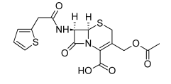 cephalothin

* **An aminothiazole ring enhances the penetration through the outer membrane of** **Gram-negative bacteria.**



* **The zwitterionic compounds( having a positively charged substituent at position 3 and a negatively charged carboxylate group at position 4) penetrate the outer membrane** **of Gram negative bacteria easily.**

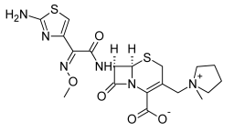

* **β-Lactamase Resistance**

1. **The “penicillinase” resistance of cephalosporins appears to be a property of the bicyclic cephem ring system rather than of the acyl group.**
2. **The introduction of polar substituents in the aminoacyl moiety of cephalosporins appears to confer stability to some β-lactamases (poor resistance). Example:**

**Cefamandole that contains hydroxyphenylacetyl (or mandoyl) group, and ceforanide, which has an o-aminophenyl acetyl group.**

1. **Steric factors also may be important in resistance to β-lactamases. Example:**

**Cefoperazone that contains an acylureidocephalosporin**

1. **Both steric and electronic( polar) properties of the alkoximino (at 7-position) group may contribute to the β-lactamase resistance. Example:**

**Cefotaxime that contain methoximino acyl group and ceftazidime, which has a 2-methylpropionic acid substituent on the oximino group.**

1.  **Methoxyl substituent at the 7α-position of the cephem nucleus contributes to increase resistance to β-lactamase. Example: Cefoxitine**



**Classification**

**Cephalosporins are divided into first-, second-, third-, and fourth-generation agents, based roughly on their time of discovery and their antimicrobial properties. In general, progression from first to fourth generation is associated with a broadening of the Gram-negative antibacterial spectrum, some reduction in activity against Gram-positive organisms, and enhanced resistance to β-lactamases.**

1. **First generation:- show good G+ activity, modest G- and poor resistance to β-lactamase (cephalexin, cefazolin, cefadroxil).**
2. **Second generation:- showed increase in G- activity and modest activity against G+ organism( cefuroxime, cefonacid, cefamondole, cefoxitine, others ) and with good resistance to β-lactamase.**
3. **Third generation:- showed greatest activity than first and second generaion against G- microorganism with good resistance to β-lactamase( cefixime, cefotaxime, ceftriaxone, others)**
4. **Fourth generation: - showed comparable activity to third generation but more resistant to some β-lactamase (cefepim).**

**Products**

**1st generation**

* **Cephalexin**



* **An orally active first generation.**
* **The α-amino group of cephalexin increases the stability against β-lactamase (poor resistance).**
* **It is active against many gram-positive but limited against gram-negative bacteria. It is used UTI, upper respiratory infection.**
* **Cefadroxil** (Duricef®)



* **p-OH derivative of cephalexin**
* **An orally active first generation.**
* **Poor β-lactamase resistance.**
* **Prolonged duration of action, which permits once-a-day dosing, that related to relatively slow urinary excretion.**
* **The antibacterial spectrum of action and therapeutic indications of cefadroxil are very similar to cephalexin.**
* **2nd generation**
* **Cefaclor**



* **Cefaclor is an orally active cephalosporin .**
* **It differs structurally from cephalexin in that the 3- methyl group has been replaced by a chlorine atom (acid atable).**
* **Poor β-lactamase resistance.**

* **Cefprozil**



* **Orally active second-generation cephalosporin.**
* **Poor β-lactamase resistance.**
* **Cefpodoxime proxetil**
* **It is the isopropyloxycarbonylethyl ester**



**of the third-generation cephalosporin cefpodoxime.**

* **This orally active prodrug derivative is hydrolysed by esterases in the intestinal wall and in the plasma to provide cefpodoxime.**
* **Tablets and a powder for the preparation of an aqueous suspension for oral pediatric**

**administration are available.**

* **Administration of the prodrug enhances its absorption.**
* **Good β-lactamase resistance.**
* **Cefuroxime and cefuroxime proxetil( H.W)**
* **Cefoxitin(H.W)**

**3rd generation**

* **Cefixime**
* 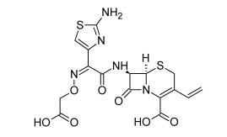**It is the first orally active(C-3 vinyl group), third-generation cephalosporin.**
* **A broad-spectrum cephalosporin that is resistant to many –lactamases.**
* **It is particularly effective against Gram-negative bacilli (aminothiazol).**
* **It is used for the treatment of various respiratory tract infections (e.g., acute bronchitis, pharyngitis, and tonsillitis) and otitis media. It is also used to treatment uncomplicated urinary tract infections and gonorrhea caused by β-lactamase–producing bacterial strains.**
* **Cefotaxime Sodium**
* **Cefotaxime (Claforan) was the first third-generation cephalosporin to be introduced.**



* **It possesses excellent broad-spectrum activity against Gram-positive and Gram negative aerobic and anaerobic bacteria.**
* **Good resistance against many β-lactamase–producing bacterial strains.**
* **Cefotaxime is metabolized in part to the less active desacetyl**

**metabolite( loses about 90% of its activity).**

* **Approximately 20% of the metabolite and 25% of the parent drug are excreted in the urine.**
* **Ceftriaxone Disodium**
* **β-lactamase–resistant cephalosporin.**
* 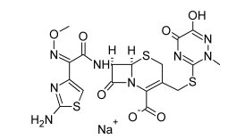**Has an extremely long serum half-life. Once-daily dosing suffices for most indications due to high protein binding in the plasma and slow urinary excretion.**
* **Ceftriaxone is excreted in both the bile and the urine.**
* **C3 side chain consists of a metabolically stable and activating thiotriazinedione in the place of acetoxy methyl group.**
* **Ceftriaxone exhibits excellent broad-spectrum antibacterial activity against both Gram-positive and Gram-negative organisms.**

**4th generation**

* **Cefepime**
* **A parenteral, β-lactamase–resistant cephalosporin.**
* **The quaternary N-methylpyrrolidine group at C-3 seems to help penetration into gram-negative bacteria.**
* **It also has a broad antibacterial spectrum, with significant activity against both Gram-positive and Gram-negative bacteria include *pseudomonas* spp..**

**5th generation**

* **Ceftaroline**
* **It does not have activity against pseudomonas aeruginosa but active against MSRA.**
* **It is a prodrug for ceftaroline.**
* **The 1,3-thiazole ring is thought to be important for its activity against MRSA.**

.



* **Ceftolozane**(H.W)